CS506 Programming for Computing
H0S02 Introduction to Python Part 2
(Lists, Tuples, Dictionary, Set)
01/16/2026 Reviewed by Clark Ngo
02/06/2026 Revised by Jonathan Koerber
09/08/2026 Reviewed by Giridhar Dronamraju

School of Technology & Computing (STC)
City University of Seattle (CityU)

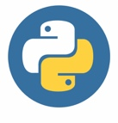
Before You Start
- Screenshots may be different from your environment.
- The directory path shown in screenshots may be different from yours.
- There might be subtle discrepancies along with the steps. Please use your best judgment while going through this cookbook-style tutorial to complete each step.
- Some steps may not be explained in detail. If you are not sure what to do:
1) Consult the resources for the course.
2) If you cannot solve the problem after a few tries (usually 15 -30 minutes), ask a TA for help.

Resources
- Python crash course: a hands-on, project-based introduction to programming: Matthes, E. (2019): Available online link

Learning Outcomes
- Section 1: Preparing your environment
- Section 2: Lists
- Section 3: Adding elements using ‘Append’
- Section 4: Inserting elements
- Section 5: Removing element
- Section 6: Using Loop in lists
- Section 7: Tuples
- Section 10: Set

Notes: If the Python command is not functioning, try using Python3 instead.

Section 1: Preparing your environment
Get started with your virtual environment here: https://cityuseattle.github.io/docs/git/getting-started-codespace/
Incorporation AI into you Learning Workflow
Like last week, it brings the future of development to our exercises. Tools like GitHub Copilot, Gemini, and ChatGPT are integrated into modern environments like GitHub Codespaces and VS Code. Our goal is to use these tools not as "answer engines," but as Socratic Tutors.
The "Socratic Tutor" Philosophy
A Socratic tutor doesn't give you the answer; they ask the right questions to help you find the answer yourself. When using AI, your goal is to understand the logic, not just the output.
Guide for best results:
- Explain, Don't Replace: Use AI to explain error messages or logic. Never copy-paste code without being able to explain what every line does.
- The 10-Minute Rule: If you are stuck on a "creative judgment" problem for more than 10 minutes, describe your problem to the AI and ask for a "hint" rather than the full solution.
- Verify the Output: AI can sometimes "hallucinate" (make mistakes). Always compare the AI’s explanation with the actual results you see.
- Cite Your Assistant: If an AI helps you solve a particularly difficult bug, add a comment in your code like: # Logic assisted by AI to resolve non-numeric error

Section 2: Lists
The list is the most versatile datatype available in Python, which can be written as a list of comma-separated values (items) between square brackets. The important thing about a list is that items in a list need not be of the same type. Creating a list is as simple as putting different comma-separated values between square brackets.
Creating, accessing, and updating values

1) Create a file called List_basic.py and type the following code

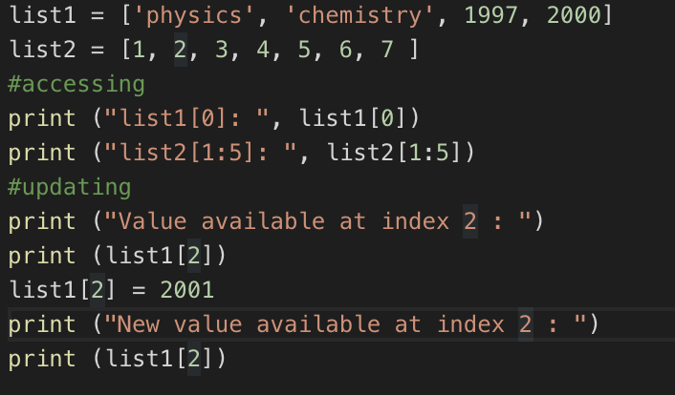

To access values in lists, use the square brackets for slicing along with the index or indices to obtain the value available at that index. Python considers the first item in a list to be at position 0, not position 1.

2) Type the following in the terminal to check the output of the above code
>>> python List_basic.py

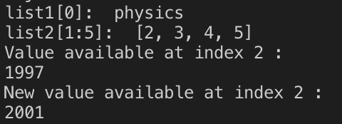

Challenge 1: Explain the code above by commenting on each line of code

Section 3: Adding elements using ‘Append’
The simplest way to add a new element to a list is to append the item to the list. When you append an item to a list, the new element is added to the end of the list. The append() method makes it easy to build lists dynamically.
In the same file, List_basic.py, add the code below

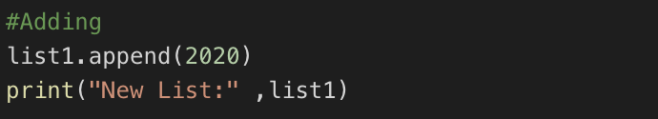

Type the following in the terminal to check the output of the above code
>>> python List_basic.py

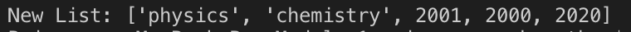

Section 4: Inserting elements
You can add a new element to any position in your list by using the insert () method. You do this by specifying the index of the new element and the value of the new item.
In the same file, List_basic.py, add the code below

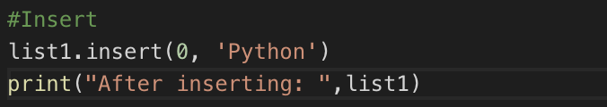

Type the following in the terminal to check the output of the above code
>>> python List_basic.py

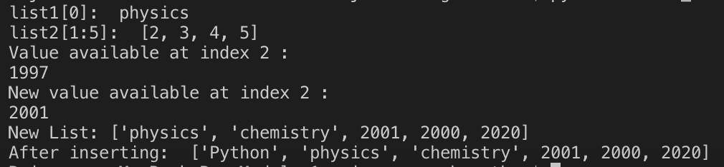
Section 5. Removing element
There are 3 ways to remove an element from a list.
- If you know the position of the item you want to remove from a list, you can use the del statement.
- The pop () method removes the last item from a list, but it lets you work with that item after removing it. The term pop comes from thinking of a list as a stack of items and popping one item off the top of the stack. In this analogy, the top of a stack corresponds to the end of a list. You can use pop () to remove an item from any position in a list by including the index of the item you want to remove in parentheses.
- If you only know the value of the item you want to remove, you can use the remove () method.

Create a file List_remove.py and type the following code.

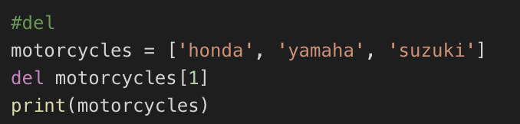

- Type the following in the terminal to check the output of the above code
>>> python List_remove.py

The del used at index 1 deletes the value Yamaha. You can no longer access the value that was removed from the list after the del statement is used.

- Add the code below to the same file

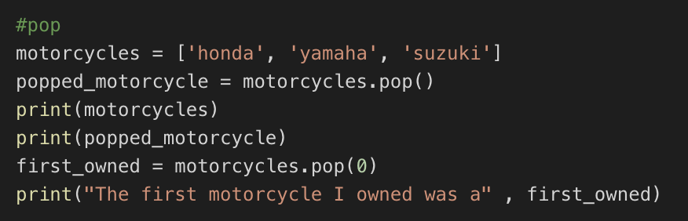

- Type the following in the terminal to check the output of the above code
>>> python List_remove.py

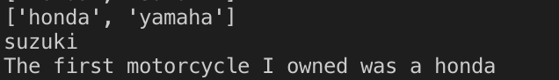
At pop(), retrieve a value from the list and store it in the variable popped_motorcycle. We print the list to show that a value has been removed from the list. Then we print the popped value to prove that we still have access to the value that was removed.
The output shows that the value ‘suzuki’ was removed from the end of the list and is now assigned to the variable popped_motorcycle.

- Add the code below to the same file

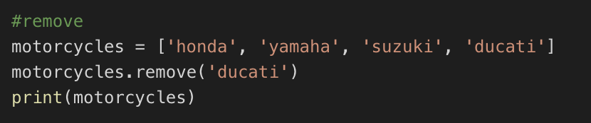

- Type the following in the terminal to check the output of the above code
>>>python List_remove.py

The code removes “Ducati” from the list. You can use the remove() method to work with a value that is being removed from a list.

Section 6: Using Loop in lists
- Let us use a for loop to print out all the elements of a list. Create a file replaceNegative.py and enter the following code:

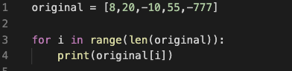

The range() function causes Python to start counting at 0, and it stops when it reaches the length of the list. The len() function calculates the length of the list. The i consists of the range index, and it is used for navigating throughout the list. If the value in the list is less than 0, it is converted to an absolute value and returned to the list.

- Type the following in the terminal to check the output of the above code
>>> python replaceNegative.py

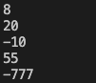
Challenge 2: Edit the program to replace any negative numbers in the list with positive ones. Expected result:

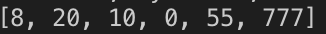

Hint: You can use the abs() function to turn negative numbers into positive numbers

Section 7: Tuples
A tuple is a sequence of immutable Python objects. The tuple data type is like a list, but with a key difference: tuples are typed with parentheses and cannot be modified, appended, or removed. The following is how tuples look.
tup1 = ('physics', 'chemistry', 1997, 2000);

- Create a tuple.py file and define a tuple with multiple data types, and try to modify the grade by assigning a 4.0 value to the item at index 1, which is 2.0

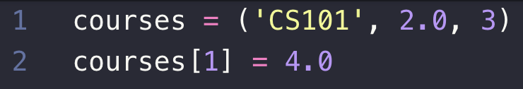

Note that you will get an error message because Tuples cannot be modified, unlike lists.

- Type the following in the terminal to check the output of the above code
>>> python tuple.py

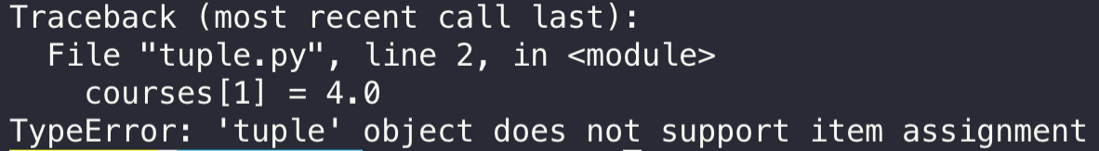

- Create a sortTuple.py with the following code to sort tuples by their first value.

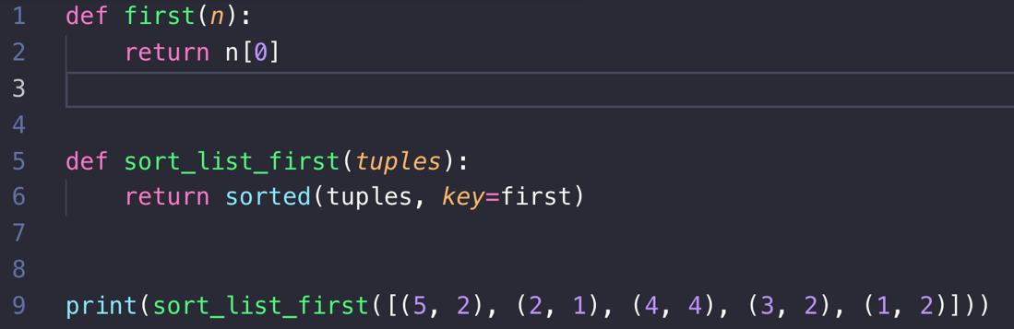

- Type the following in the terminal to check the output of the above code
>>> python sortTuple.py
Output will be sorted.

“def” is the function, and it will be explained in the later chapters. the sort function takes in a keyword argument called key. What it does is provide a way to specify a function that returns what you would like your items sorted by. The function receives an "invisible" argument representing an item in the list and returns a value to serve as the item's "key" for sorting.

Challenge 3: Using AI if needed, change the way this code sports to sort based on the sum of the tuple. Remember to record a list of prompts.

Section 10: Set
A set is an unordered and unindexed collection. In Python, sets are written with curly brackets.
Example: thisset = {"apple", "banana", "cherry"}

- Accessing items: You cannot access items in a set by referring to an index, since sets are unordered, and the items have no index. But you can loop through the set of items using a loop or ask if a specified value is present in a set by using the keyword.
- Modify items: Once a set is created, you cannot change its items, but you can add new items.
- Add items: To add one item to a set, use the add () method. To add more than one item to a set, use the update () method.
- Remove items: To remove an item from a set, use the remove () or the discard () method.
- Joining two sets: There are several ways to join two or more sets in Python. You can use the union () method that returns a new set containing all items from both sets, or the update () method that inserts all the items from one set into another.

Constructor: It is also possible to use the set () constructor to make a set.

- Create a file Set.py and type the following program to understand how the joining of two sets works and the constructor.

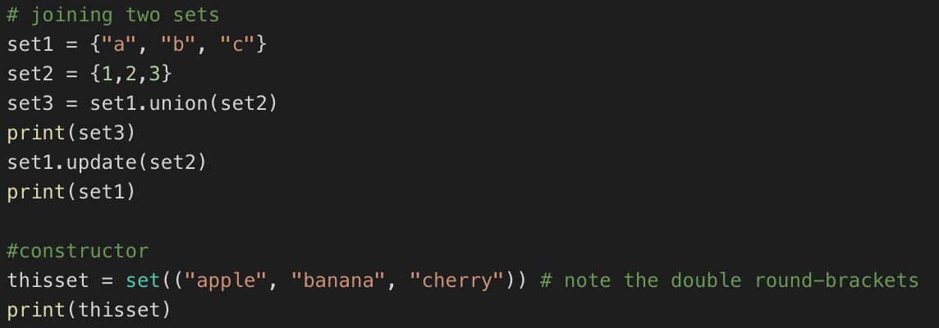
Type "python Set.py" in the terminal to view the output.

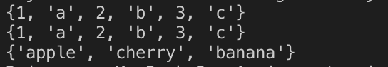

Note: Both union () and update () will exclude any duplicate items.

Challenge: Using AI, create a set of unique items.

Push your work to GitHub Codespaces:
Follow instructions here: https://cityuseattle.github.io/docs/git/github_upload_files/

